DSA3050A- GROUP PROJECT
GROUP PROJECT: E-COMMERCE LAST-MILE AND FULFILLMENT INTELLIGENCE PROJECT
GROUP MEMBERS
KAREN KISIANG’ANI-672211
EDWARD GELAZO-
GITHUN REPOSITORY- shttps://github.com/Kareneks/DSA3050A_LOGISTICS_PROJECT.
DATA PROFILING
Problem Statement: A major e-commerce retailer is experiencing a high rate of late deliveries. Without understanding which carriers, warehouses or weather conditions are driving these delays, the company cannot prioritize operational improvements or reduce customer dissatisfaction. Audience: Head of Logistics, Warehouse Operations Managers and Carrier Relationship Teams.
Analytical Questions
- How do weather conditions e.g storms or snow impact delivery delays and which warehouses are most exposed?
- Is there a relationship between shipping distance and delivery delay duration?
- Which shipping carriers have the highest late delivery rates and does this vary by warehouse location?
- Which product categories are most associated with returns and does a late delivery increase the likelihood of a return?
- How does customer satisfaction (ratings) correlate with actual delivery days versus the promised delivery date?
Five KPIs:
- On-Time Delivery Rate: Percentage of orders delivered on or before the promised date.
- Average Delay Duration: Mean number of days late for delayed orders.
- Carrier Performance Score: Ranking based on on-time rate and average delay.
- Weather Delay Risk: Percentage of delays attributed to adverse weather.
- Return Rate: Percentage of delivered orders resulting in a product return.
Dataset Details:
- URL: https://www.kaggle.com/datasets/datascikhan/e-commerce-delivery-and-shipping-data-2026
- Row Count: 50,000
- Column Count: 30
- Licence: CC0: Public Domain
- Ethics: Fully anonymized, no Personally Identifiable Information.
- Limitation: The dataset uses production grade operational logic but real-world carrier costs and contracts are not included.

Dataset Profile
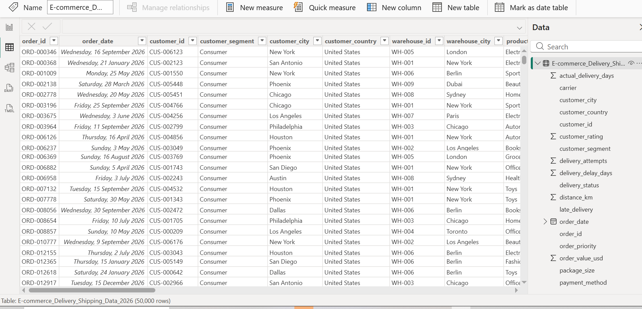
- order_id: Unique identifier for each order (Text).
- order_date: The date the order was placed (Date).
- warehouse_id: The ID of the warehouse fulfilling the order (Text).
- carrier_id: The shipping company handling the delivery (Text).
- promised_delivery_date: The date the customer was told to expect the package (Date).
- actual_delivery_date: The date the package actually arrived (Date).
- is_late_delivery: A binary flag (1 = late, 0 = on time).
- weather_condition: Weather at the time of dispatch (e.g., Clear, Rain, Snow).
- customer_rating: Customer satisfaction score (Number).
- return_status: Whether the item was returned (Text).
Data Limitations & Missingness:
During initial profiling, we noted missing values in the weather_condition column. There are also potential nulls in the return_reason column (which is expected, as not all orders are returned). All personally identifiable information (PII) is removed from this dataset, ensuring compliance with privacy standards.

POWER QUERY AND DATA QUALITY
1) Raw Data Screenshots
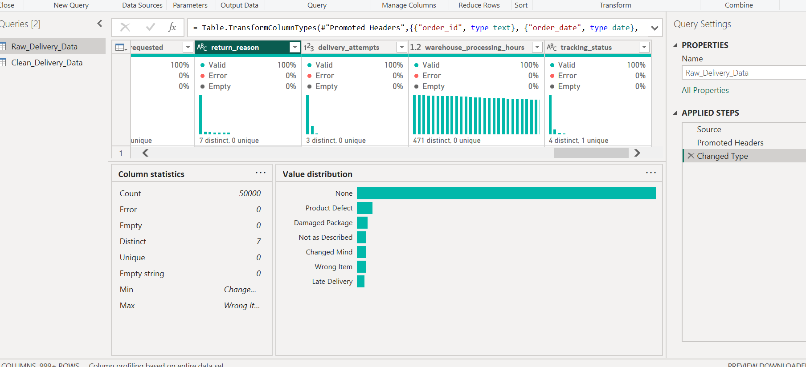

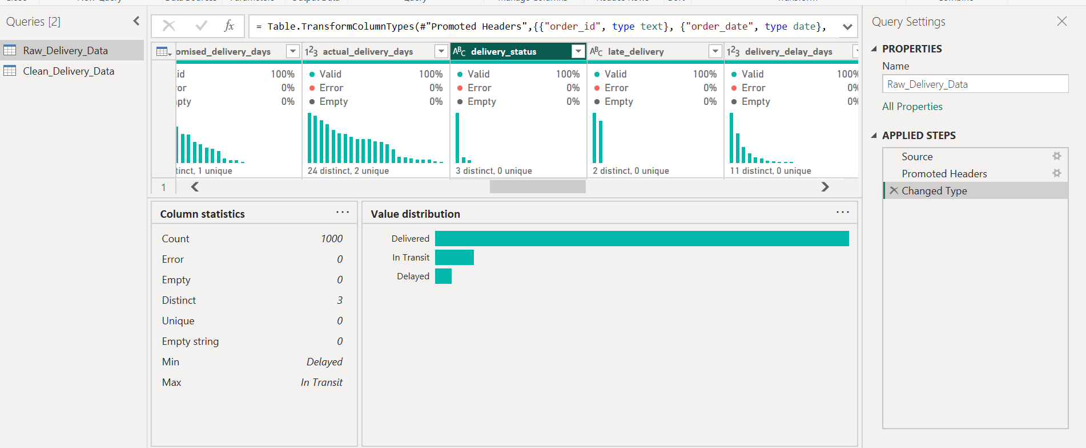

2) Clean Data Screenshots
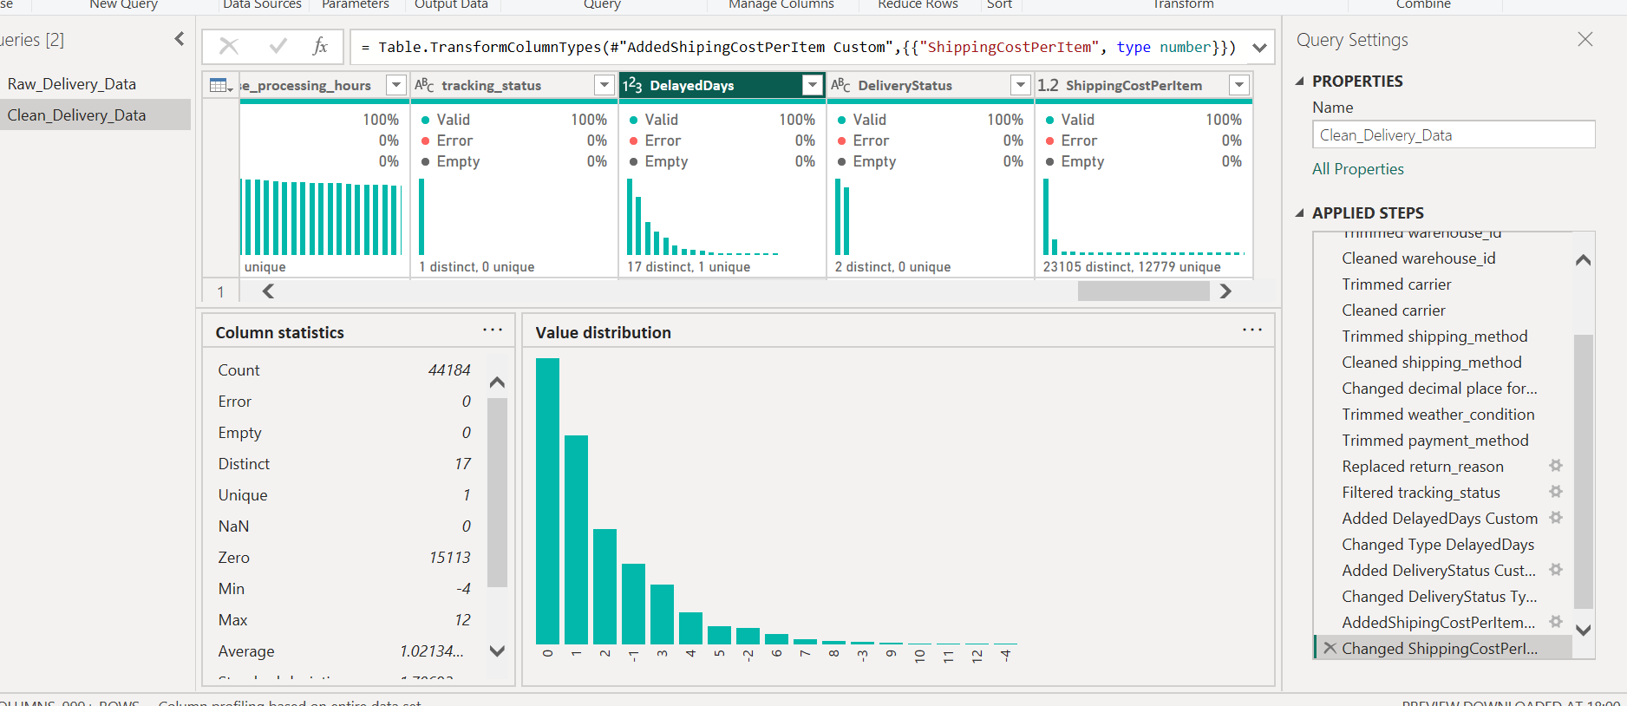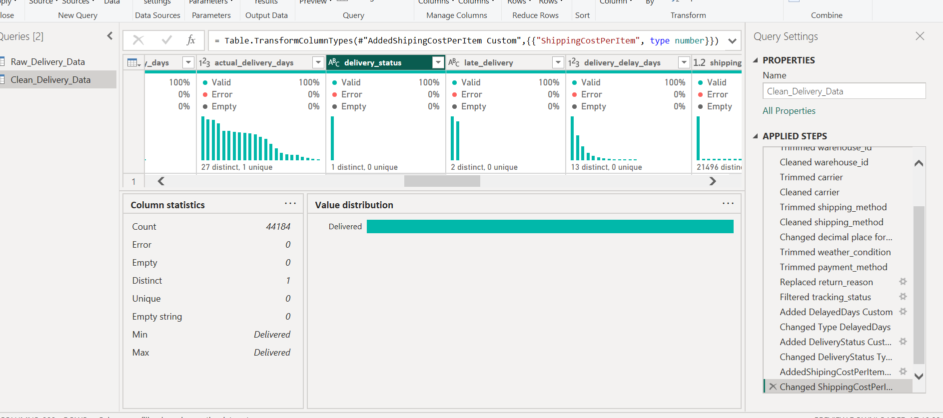
The Transformation Log
Power Query Transformation Log
Dataset: E-commerce Delivery Analytics has 50,000 rows and 30 columns.
Objective: Clean data, handle anomalies and derive time-based delivery metrics for delay analysis.
Transformation Operations:
- Changed Data Types: Converted order_date to Date, and promised_delivery_days, actual_delivery_days, and shipping_cost_usd to numeric types to enable mathematical calculations.
- Removed Blank Rows: Eliminated completely empty rows to ensure accurate row counts and prevent null errors in visuals.
- Trimmed and Cleaned Text: Applied Trim and Clean to shipping_method, weather_condition, and payment_method to remove invisible spaces and standardize categories for grouping.
- Standardized Null Values: Replaced "None" values in the return_reason column with "Not Returned" for clearer reporting.
- Filtered In-Transit Orders: Filtered the tracking_status column to only include "Delivered" orders, ensuring the analysis focuses on completed fulfillment.
- Derived Column - DelayedDays: Created a custom column: [actual_delivery_days] - [promised_delivery_days]. Positive numbers indicate a late delivery.
- Derived Column - DeliveryStatus: Created a conditional column to classify orders as "Late" (if DelayedDays > 0) or "On Time" (if DelayedDays <= 0).
- Derived Column - ShippingCostPerItem: Created a custom column: [shipping_cost_usd] / [delivery_attempts] to understand the cost efficiency per delivery attempt.

QA Summary:
Verified there are no exact duplicate rows. After transformation, the new DeliveryStatus and DelayedDays columns show 100% Valid (0% Error, 0% Empty) in Power Query Column Quality profiling. The cleaned dataset retains exactly 44,184 valid delivered orders for analysis after data quality check.

